**hostname:**

displays the hostname i.e. MasterImage



**ipconfig:**

displays the internet protocols of the computer.

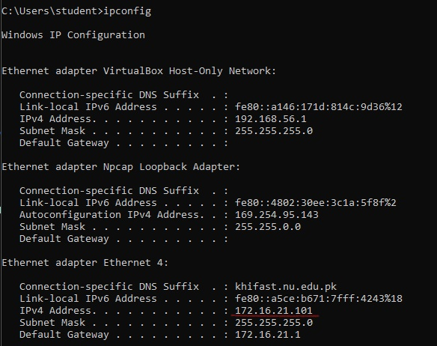

The IP Address underlined with red is the outsider IP address of the computer.

**nslookup:**

lists the computers that have joined the domain.

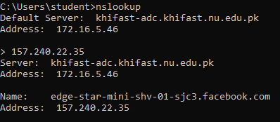

**tracert:**

used to trace route from host to a destination through an internet router.

Here, we are accessing the route from this computer to the google server.

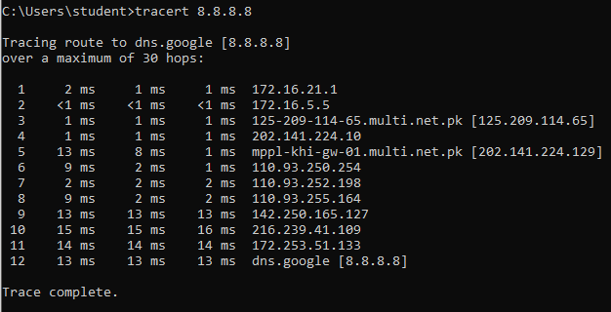

**ping:**

to check if a host can be accessed through IP or name.

Here, we checked if the current computer is connected to google or not.

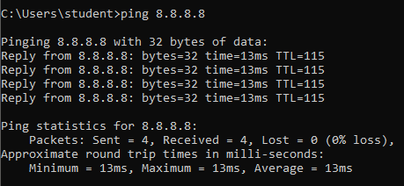

**netstat:**

shows the active connections.

